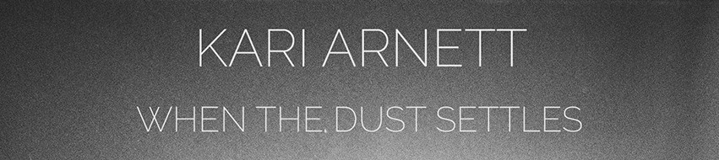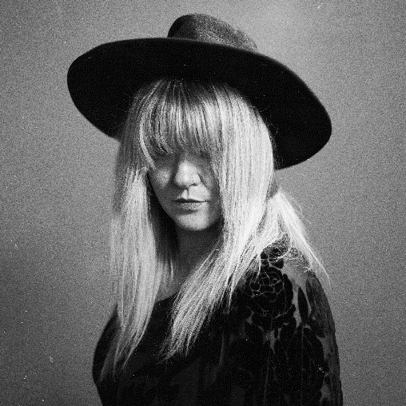

**PUBLICITY –** **Tinderbox Music**

Krista Vilinskis

3148 Bryant Ave. S

Minneapolis, MN 55408

Phone – 612-375-1113 Email: **krista@tinderboxmusic.com**

**1. Dark Water (4:24)\***

**2. Blood and Bones (3:48)\***

**3. One More Chance (4:25)\***

**4. This American Life (4:44)\***

5. Breaking Is Easy (5:52)

6. Starting Over (4:54)

7. When The Dust Settles (3:38)

8. Tired of This Town (4:49)

**9. Only a Woman (4:44)\***

10. The War (5:27)

11. When You Were Mine (4:29)

**ALL TRACKS FCC CLEAN**

**\*SUGGESTED TRACKS: 1, 2, 3, 4, 9**

**WWW.KARIARNETT.COM**

All tracks FCC clean

**GOING FOR ADDS**

October 2nd, 2018

**THE ALBUM**

Singer/songwriter, Kari Arnett has always been fluent in the language of music, crafting songs and wielding them into heartbreaking Americana.

Influenced by the work of Lori McKenna, Patty Griffin, and Caroline Spence, she partnered with producer/engineer, **Danny O'Brien** (*Hot Dad Labs : Minneapolis, MN*) along with her full band to bring her deepest and most raw songs to life.  With her debut full-length release,***When The Dust Settles***, Arnett offers 11 tracks showcasing her affinity for lonesome melodies, authentic lyricism, and a vulnerable grit as honest as her songs, inhabiting the folk-country borderlands.

Building momentum from her well received EP release in 2015, *Midwestern Skyline,*had solidified her place on the Americana scene as an artist coming into her own through her personal breakthrough.  Her first single, "Heavy Heart", garnered praise as a Daily Discovery from **American Songwriter** (Nashville,TN), as well as critical acclaim from other local and national music critics, earning garnered radio play and new fans across the globe.  Kari continues to tour on a national basis and has opened for folk-country luminaries such as Erin Rae, Michael McDermott, Frazey Ford, Paul Thorn, and more.

Her new album, ***When the Dust Settles***, will be released on September 20, 2018.

**THE MUSICIANS**

**Kari Arnett** - Vocals, Acoustic Guitar

**Jason Scabich** - Electric Guitars

**Haley Rydell** - Fiddle, Harmony Vocals on Tracks 1 & 7

**Alexander Young** - Drums

**Andy Schuster** - Bass

**Aaron Fabbrini** - Pedal Steel

**Ben Cook-Feltz** - Piano/Keys/Mellotron on Track 3

**PRESS**

“*Kari Arnett is one of the hardest working Americana artists in the Twin Cities scene. There is some sharp songwriting on this touching batch of songs.****When the Dust Settles****is her best yet!”* – **Bill DeVille, DJ & Host of United States of Americana on 89.3 The Current**

“*It’s exciting when a new voice emerges that feels like it is meant to soon become one of your standards. Even more so when that voice sits on a foundation of strong songwriting and storytelling.” –* **Shana, Revival Music Magazine Los Angeles**

*"Melancholy is an ever-present force in the voice of Kari Arnett. Backed with the ethereal melodies of Americana, Kari Arnett uses the space in between the notes as a secret ingredient in the songs she collects. –* **Danny McCloskey, The Alternate Root**

**SOCIAL MEDIA**

[**www.kariarnett.com**](http://www.kariarnett.com) | **email: info@kariarnett.com**

**facebook.com/kariarnettmusic**

**twitter.com/kariarnett**

