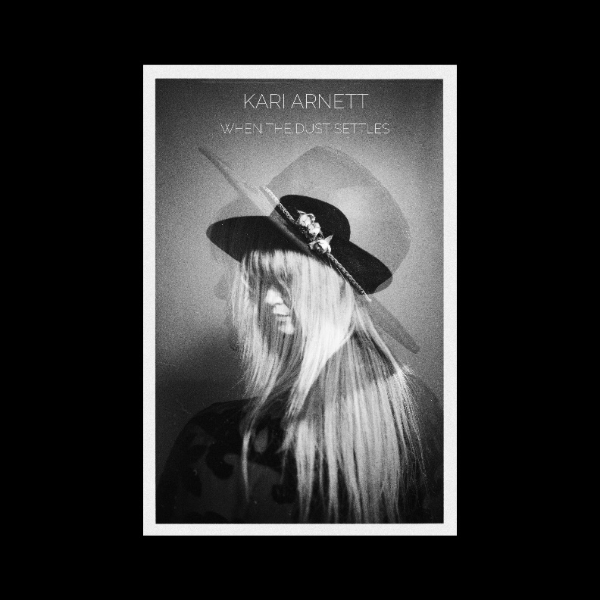
When The Dust Settles is the debut full-length release from Americana singer/songwriter, Kari Arnett. This album showcases Arnett’s affinity for lonesome melodies, authentic lyricism, and a vulnerable grit as honest as her songs, inhabiting the folk-country borderlands. Arnett’s way of articulating the love, pain, and the struggle of the American Life makes this her most personal album to date. Together with her full band they created a raw sound, from warm, vintage acoustics to a retro, cinematic feel on some of the songs. Recorded and mixed in Minneapolis, MN with Producer Danny O’Brien (Hot Dad Labs) and Mastered by Huntley Miller, When The Dust Settles is a collection of deeply personal songs with universal appeal.
- DARK WATER *
- BLOOD AND BONES *
- ONE MORE CHANCE *
- THIS AMERICAN LIFE *
- BREAKING IS EASY
- STARTING OVER
- WHEN THE DUST SETTLES
- TIRED OF THIS TOWN
- ONLY A WOMAN *
- THE WAR
- WHEN YOU WERE MINE
ALL TRACKS FCC CLEAN
* denotes suggested tracks
Kari Arnett is currently based in Minneapolis, MN and originally from the Madison, WI area and has toured nationally, and was featured in American Songwriter Magazine (Nashville, TN) from her first EP, Midwestern Skyline as well as garnered attention from other local and national critics.
“Kari Arnett is one of the hardest working Americana artists in the Twin Cities scene. There is some sharp songwriting on this touching batch of songs. When The Dust Settles is her best yet!”
ALBUM MUSICIANS:
KARI ARNETT – VOCALS, GUITAR
JASON SCABICH – ELECTRIC GUITARS
HALEY RYDELL – FIDDLE, HARMONY VOCALS tracks 1 & 7
BEN COOK-FELTZ – PIANO/KEYS
ALEXANDER YOUNG – DRUMS
AARON FABBRINI – PEDAL STEEL
ANDY SCHUSTER - BASS
-Bill DeVille – The Current - DJ & Host of United States of Americana
CONTACT: Tinderbox Music
Krista Vilinskis – email: krista@tinderboxmusic.com
612-375-1113 | www.tinderboxmusic.com
WWW.KARIARNETT.COM

